MIS 273 Lab: Configuring disks and Volumes

This lab contains the following exercises:

|  |  |
| --- | --- |
| Exercise: 1 | Configuring Disks and Volumes |
| Exercise: 2 | Managing NTFS and Share Permissions |

BEFORE YOU BEGIN

The lab environment consists of your installation of Windows Server 2016 or 2019 running within a virtual machine (VM). You can use your hypervisor of choice (VMware, VirtualBox, Hyper-V, KVM, bhyve, QEMU, etc.). Further, you can use the Windows Server VM that you installed in the previous lab.

Working with Lab Worksheets

Each lab requires that you answer questions, take screen shots, and perform other activities that you will save in this document for the lab. As you perform the exercises in each lab, fill in the required information, and then save the file. After the lab is completed, you’ll upload the file to Canvas.

The exercises in this lab relate to information from chapters 3 and 4. After completing this lab, you will be able to:

Configure Disks and Volumes

Manage NTFS and Share Permissions

Create, Configure, and Mount VHDs

|  |  |
| --- | --- |
| NOTE | The instructions here assume you’re using a computer running Windows Server 2016 or 2019 with a hypervisor (VMware, VirtualBox, or Hyper-V) installed. |

|  |  |
| --- | --- |
| Exercise 1 | Configuring Disks and Volumes |
| Overview | In this exercise, you will first create a simple volume. You will then expand the simple volume. |
| Mindset | A simple volume is a type of volume that uses free space available on a single disk. Because it requires only a single disk, a simple volume is the quickest and easiest to set up. |
| Completion time | 20 minutes |

1. In order to make additional disks available to configure you’ll have to create virtual disks using your virtual machine management software. Watch the video entitled “Creating Virtual Disks” provided on Canvas to see how it’s done with VirtualBox.
2. After creating two virtual disks, start your server and log on as **administrator** with the password you created when installing the server.
3. Right-click the **Start** button and choose **Disk Management**.
4. In Disk Management, as shown in Figure 3, click **Action** **>** **Rescan Disks**.

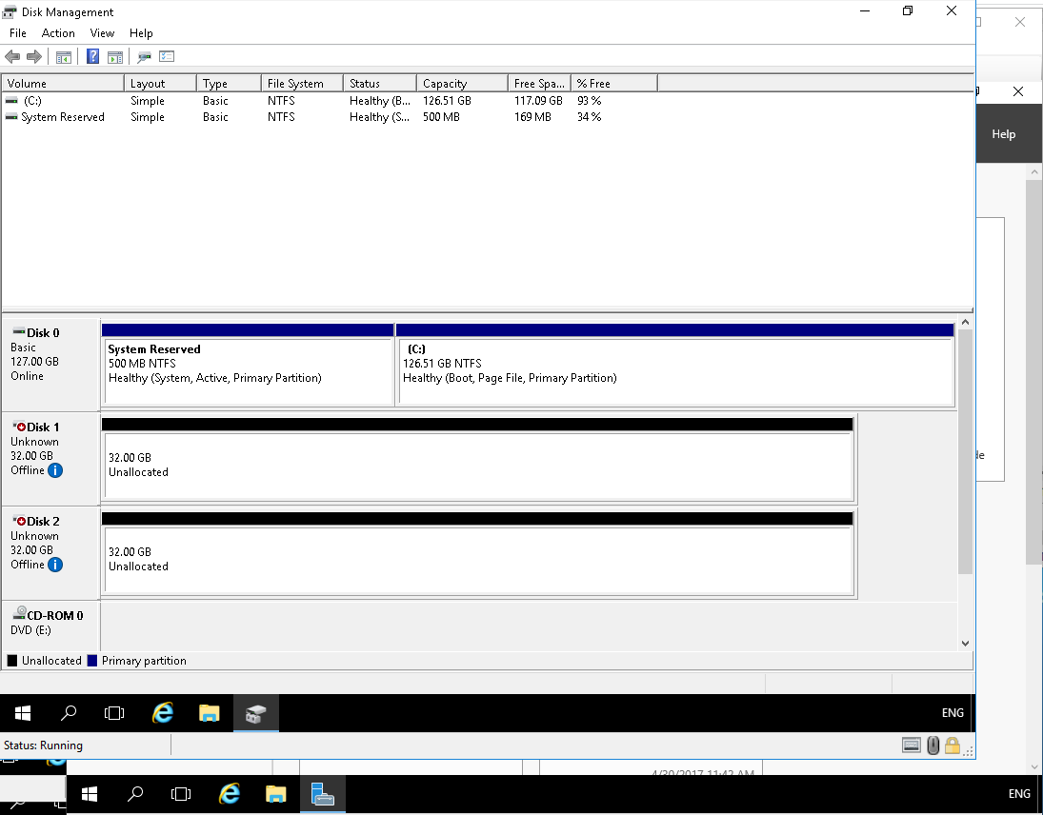

Figure 3: The Disk Management program

1. Right-click the virtual disk you created and choose **Online** if it is not already online.
2. Right-click the **“Not Initialized”** disk and choose **Initialize Disk** if it is not already initialized.
3. When you are prompted to select a partition system, answer the following question and then click click **OK**. In Server 2019 you may be prompted to select the partition style and initialize the disk when you first start the Disk Management program. It will likely show MBR as the default partition style.

|  |  |
| --- | --- |
| Question 1 | What are the two partition styles?  NTFS & UDF |

1. Right-click an empty area (unallocated space) of this disk and choose **New Simple Volume**.
2. In the New Simple Volume Wizard, on the Welcome page, click **Next**.
3. On the Specify volume Size page, answer the following question and then click **Next**.

|  |  |
| --- | --- |
| Question 2 | How large will the simple volume be?  The entire size of the partion or less |

1. On the Assign Drive Letter or Path page, answer the following question and then click **Next**.

|  |  |
| --- | --- |
| Question 3 | Which drive letter will be assigned to the volume.  E |

1. On the Format Partition page, answer the following question. Then, for the Volume label text box, type **Data** and click **Next**.

|  |  |
| --- | --- |
| Question 4 | What is the default file system?  NTFS |

On the Completing the New Simple Volume Wizard page, take a screen shot of the New Simple Volume Wizard by pressing **Alt+PrtScr** and then paste it into this document below by pressing **Ctrl+V**.

[You cant copy and paste the image into the word doc. It covers the image with a white background, so im putting all screen prints in a compressed zip with this file. This will be called IMG1]

1. Click **Finish**. If you are prompted to format the disk, click **Cancel**.

Remain logged on to **your server** for the next exercise.

|  |  |
| --- | --- |
| Exercise: 2 | Managing NTFS and Share Permissions |
| Overview | In this exercise, you will create a folder, share the folder, and then configure the NTFS and share permissions for that folder. |
| Mindset | As a Windows administrator, you need to know how to manage files and folders, including how to configure NTFS and share permissions so that users can access the files that they need in order to perform their jobs while preventing other users from accessing those same files. |
| Completion time | 30 minutes |

1. Log on to your server as **administrator**. Before you can accomplish the remainder of this exercise, you’ll need to install Active Directory Domain Services and promote your server to a Domain Controller. To see how, watch the video on Canvas entitled “Install Active Directory Domain Services.”
2. Using Server Manager, click **Tools > Active Directory Users and Computers**. The Active Directory Users and Computers console opens, as shown in Figure 4.

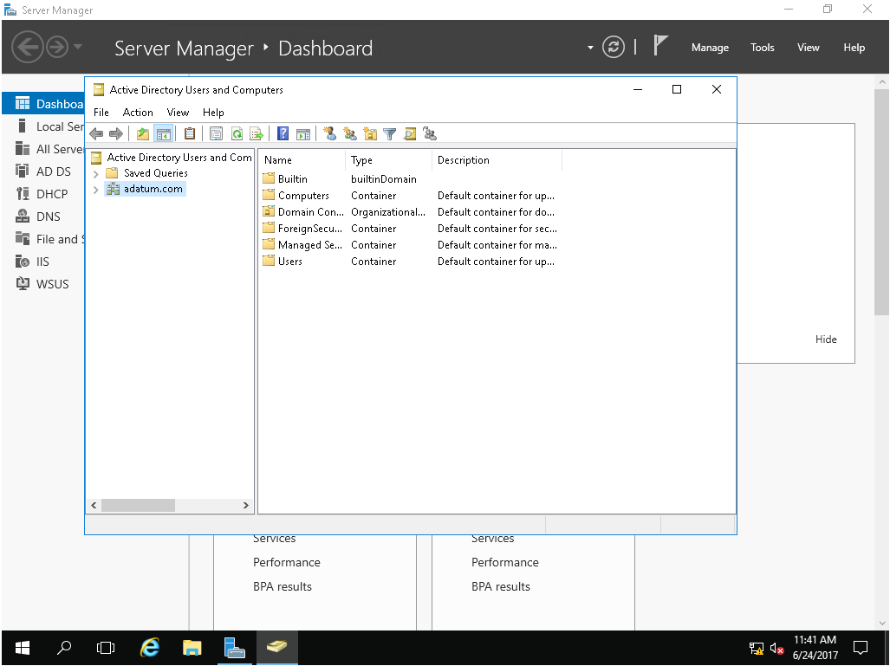

Figure 4: The Active Directory Users and Computers console

1. Right-click the **Users** OU and choose **New > User.**
2. In the New Object – User dialog box, type the following and then click **Next**.

First Name: **usernameFirst**

Last Name: **usernameLast**

User logon name: **usernameYouCreated**

1. Enter a password and keep track of it. Click to **deselect** **User must change password at next logon** and then **select** **Password never expires**. Click **Next**.
2. Click **Finish**.
3. Close **Active Directory Users and Computers**.
4. On the taskbar, open File Explorer by clicking the **File Explorer** icon.
5. Under This PC, click **Local Disk (C:)**. Then right-click **Local Disk (C:)** and choose **New > Folder**. For the folder name, type **Data** and press **Enter**.
6. Right-click the **Data** folder and choose **Properties**.
7. Click the **Sharing** tab.
8. Click the **Advanced Sharing** button.
9. Click to select **Share this folder**.
10. To configure the share permissions, click the **Permissions** button.
11. With Everyone already selected, click to select **Allow Full Control**.
12. Click **OK** to close the Permission for Data dialog box.
13. At this point, it is recommended that you review the information between Share Permissions and NTFS Permissions in chapter 3 of the book.
14. Click **OK** to close the Advanced Sharing dialog box.
15. To manage the NTFS permissions, click the **Security** tab.

|  |  |
| --- | --- |
| Question 6 | Which permissions do Users have?  Read&execute, list folder contents, read, special permissions |

1. Click the **Advanced** button.
2. In the Advanced Security Settings for Data dialog box (see Figure 5), click the **Effective Access** tab.

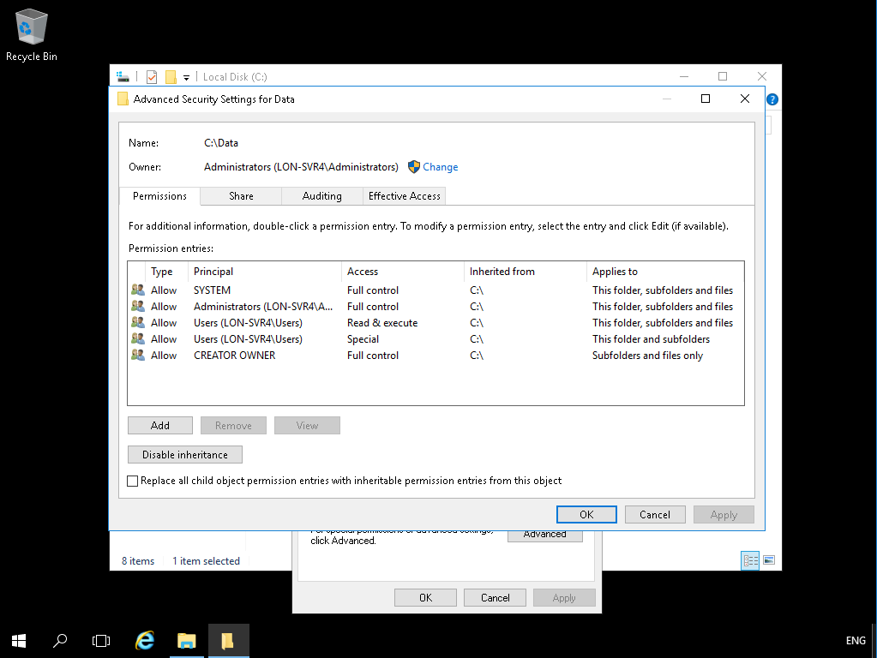

Figure 5: The Advanced Security Settings for Data dialog box

1. Click **Select a user**.
2. In the Select User, Computer, Service Account, or Group dialog box, in the Enter the object name to select text box, type login name of the user you created above and then click **OK**. Note: You can get a list of all the users by selecting the Advanced button and in the next dialog box selecting the Find Now button.
3. Click the **View effective access** button.

|  |  |
| --- | --- |
| Question 7 | Which security (NTFS) permissions does the **user you created** have for the Data folder at this point? Displaying a screen print below that shows the effective access for each permission below to answer this question is acceptable. Those with a red X are not allowed. Those with a green check mark are allowed  IMG2 |

1. Click **OK** to close the Advanced Security Settings for Data dialog box.
2. Click the **Edit** button.
3. In the Permissions for Data dialog box, click **Add**.
4. In the Select Users, Computers, Service Accounts, or Groups dialog box, in the Enter the object names to select text box, type the login name of the user you created and then click **OK**.
5. Select the user you created and click to select **Allow Full control**.
6. Click **OK** to close the Permissions for Data dialog box.
7. In the Data Properties dialog box, click the **Advanced** button.
8. Click the **Effective Access** tab.
9. Click **Select a user**.
10. In the Select User, Computer, Service Account, or Group dialog box, in the Enter the object name to select text box, type login name of the user you createdand then click **OK**.
11. Click the **View effective access** button.

|  |  |
| --- | --- |
| Question 8 | What are the effective permissions of the user you created now for the Data folder now? Again you can paste a screen print below to answer this question?  IMG3 |

1. Click **OK** to close the Advanced Security Settings for Data dialog box.
2. Close the Data Properties dialog box.

Close all windows on your server before shutting down the server.